UNITED STATES

SECURITIES AND EXCHANGE COMMISSION

WASHINGTON, D.C. 20549

FORM 6-K

REPORT OF FOREIGN PRIVATE ISSUER

PURSUANT TO RULE 13a-16 OR 15d-16

UNDER THE SECURITIES EXCHANGE ACT OF 1934

For the month of June 2026

Commission File Number: 001-42213

WeRide Inc.

21st Floor, Tower A, Guanzhou Life Science Innovation Center

No. 51, Luoxuan Road, Guangzhou International Biotech Island

Guangzhou 510005

People’s Republic of China

(Address of principal executive offices)

Indicate by check mark whether the registrant files or will file annual reports under cover of Form 20-F or Form 40-F.

Form 20-F ☒ Form 40-F ☐

EXPLANATORY NOTE

We submitted a monthly return form dated June 4, 2026 in relation to the movements in our authorized share capital and issued shares in May 2026 to The Stock Exchange of Hong Kong Limited. For details, please refer to Exhibit 99.1 to this current report on Form 6-K.

EXHIBIT INDEX

Exhibit No. |  |  | Description
99.1 |  |  | Monthly Return for Equity Issuer on Movements in Securities
99.2 |  |  | Next Day Disclosure Return, dated June 4, 2026

SIGNATURES

Pursuant to the requirements of the Securities Exchange Act of 1934, the registrant has duly caused this report to be signed on its behalf by the undersigned, thereunto duly authorized.

WeRide Inc.

By: | /s/ Jennifer Li
Name: | Jennifer Li
Title: | Chief Financial Officer

Date: June 4, 2026

Exhibit 99.1
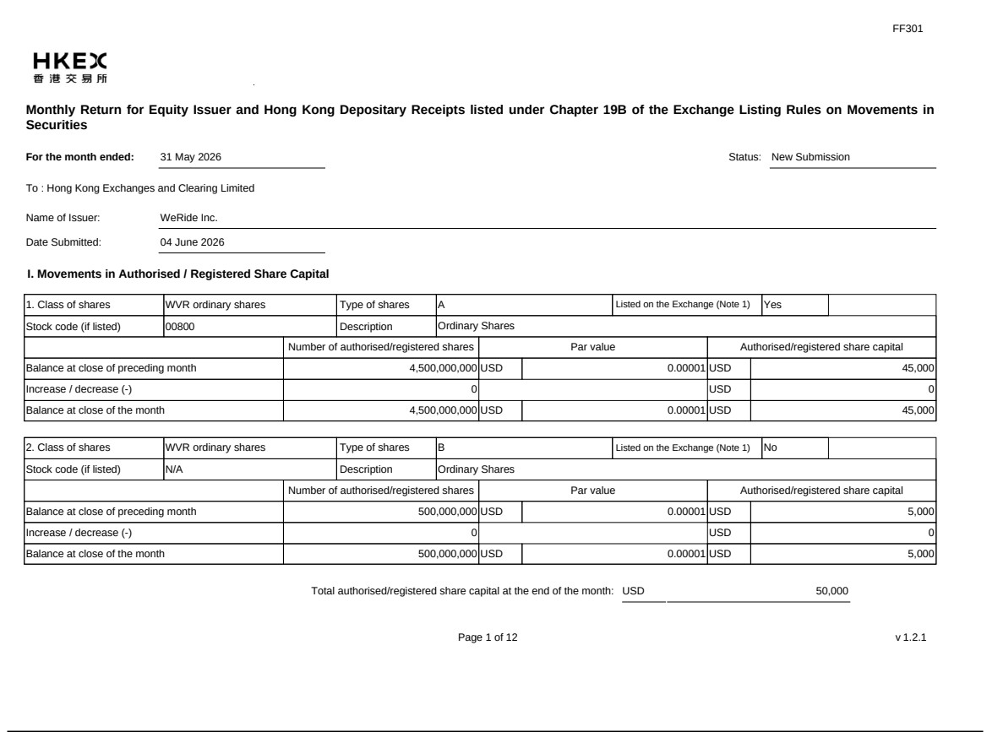

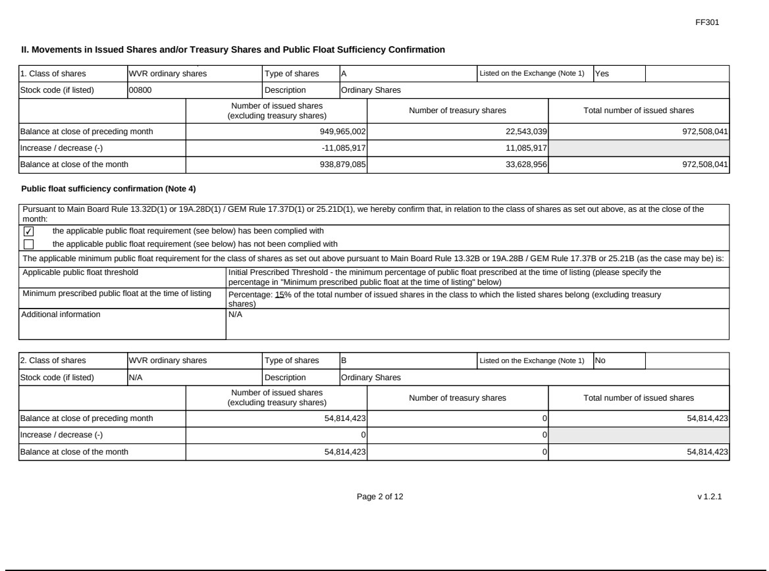

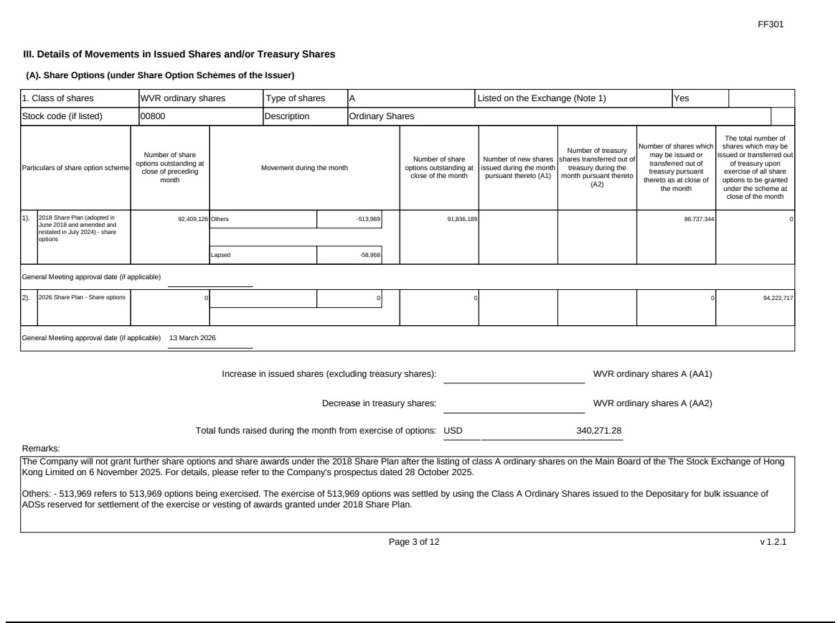

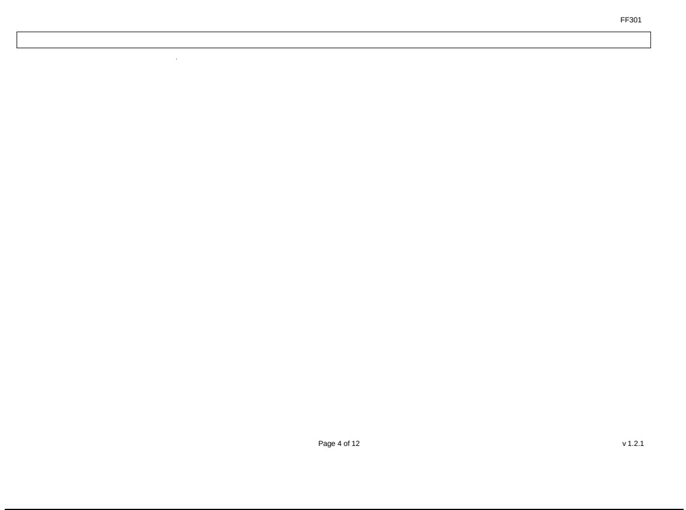

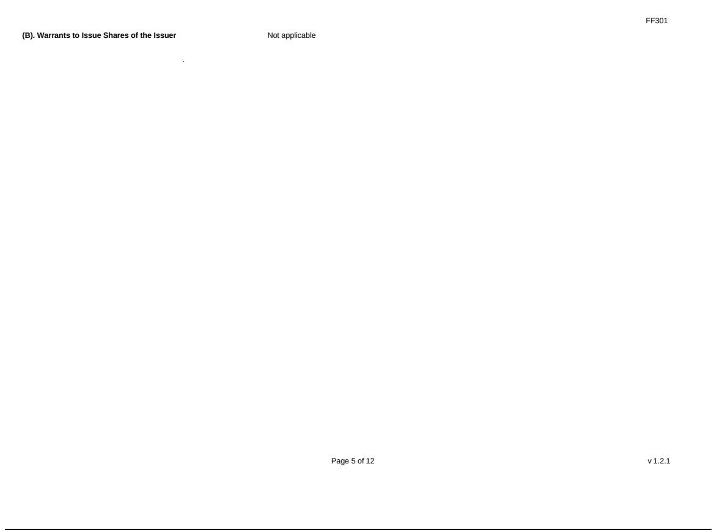

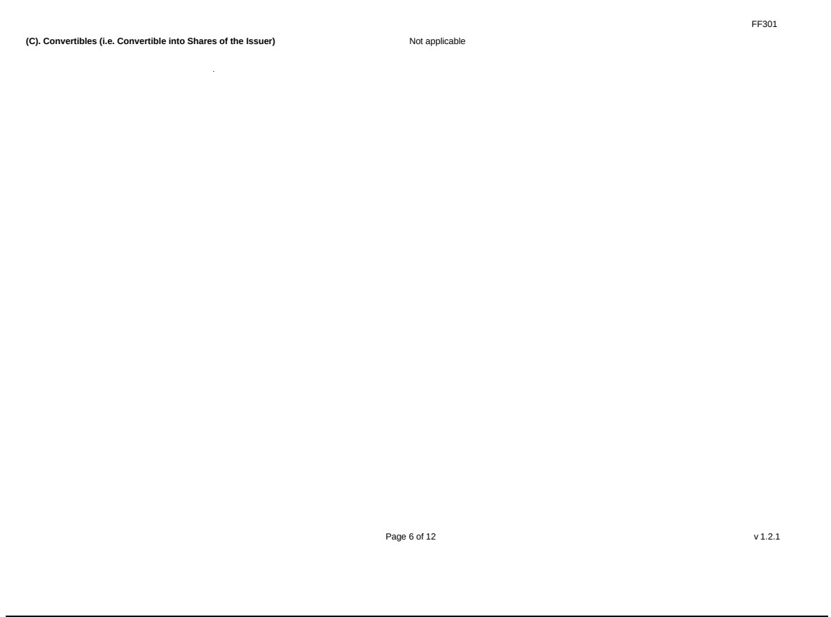

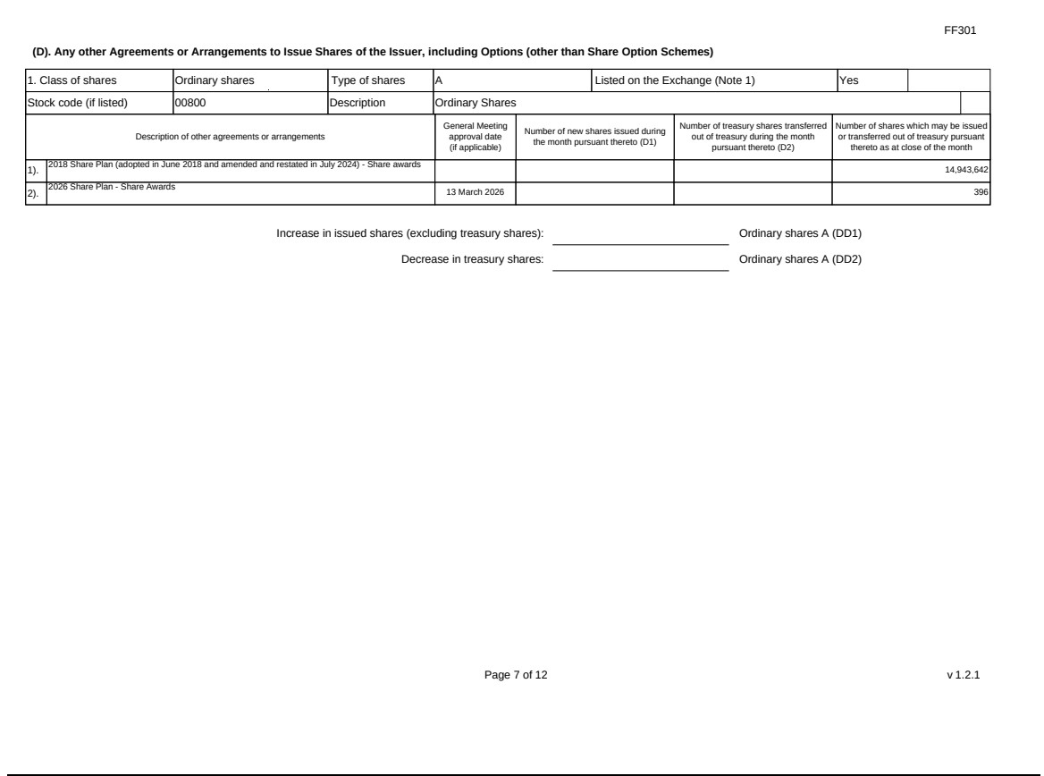

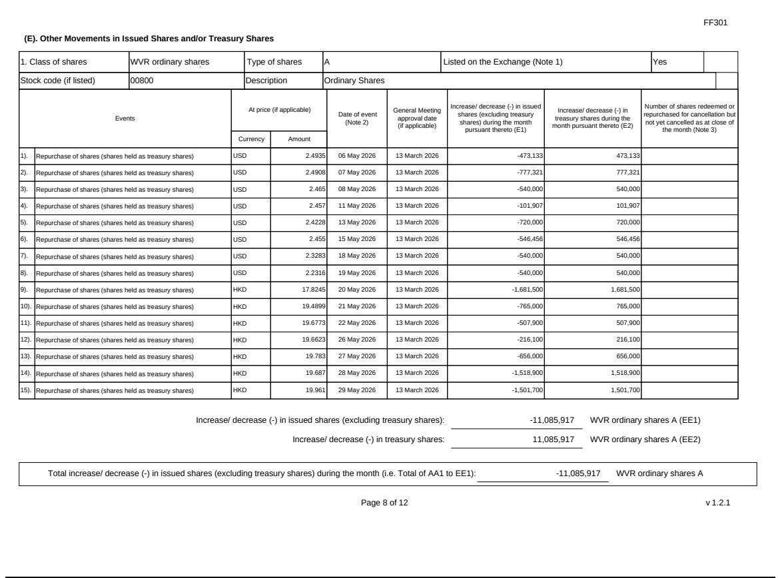

s
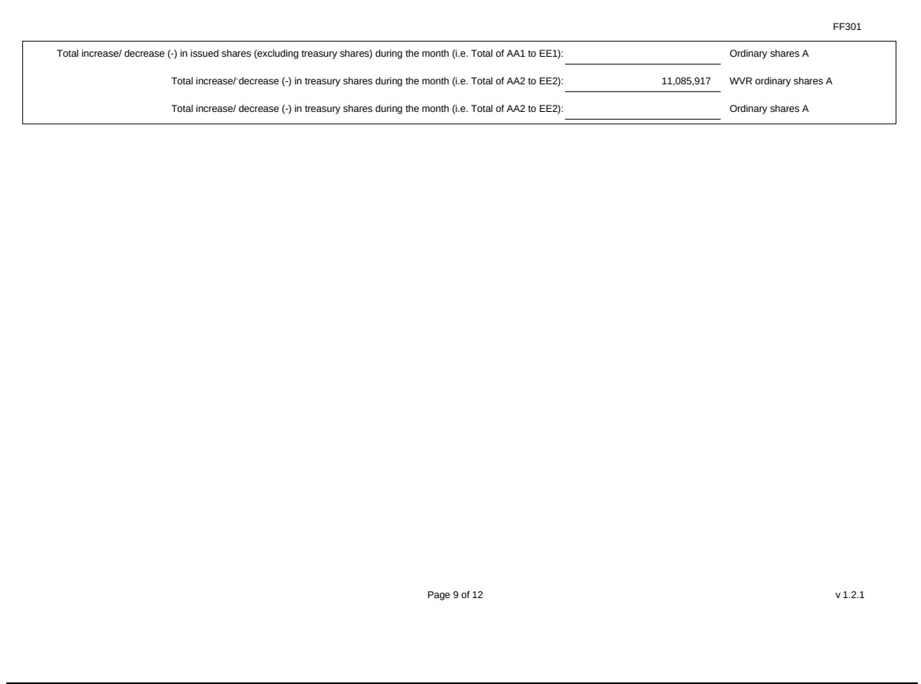

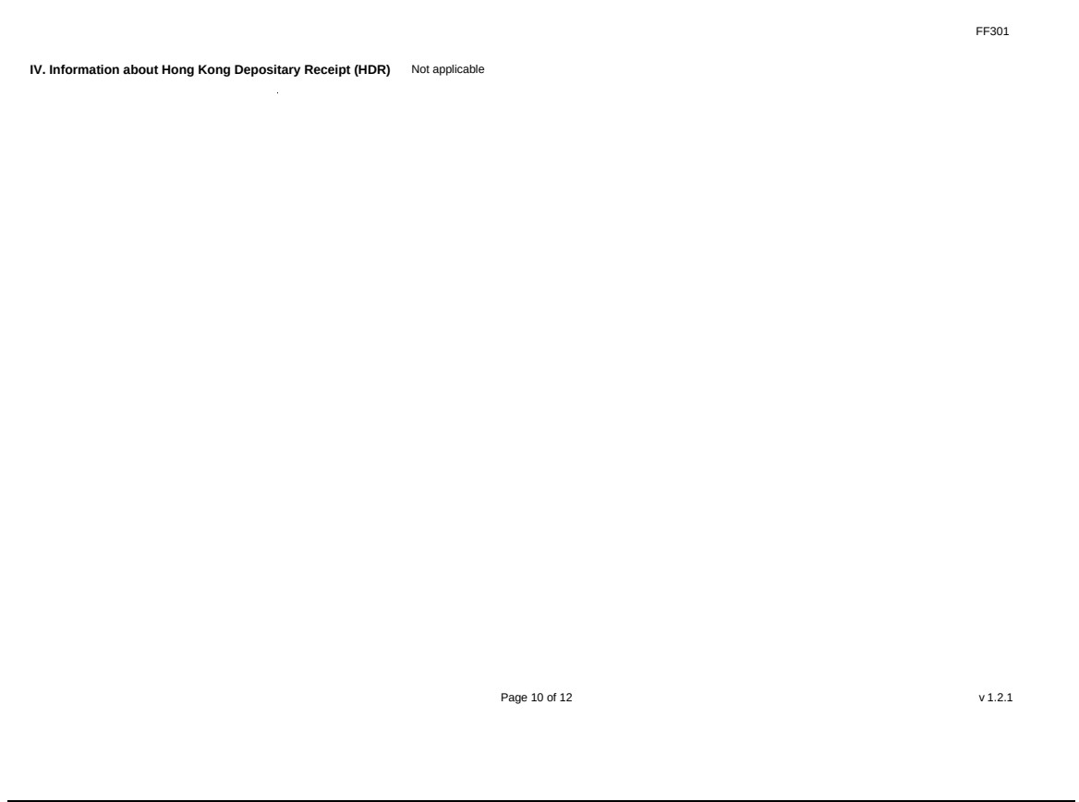

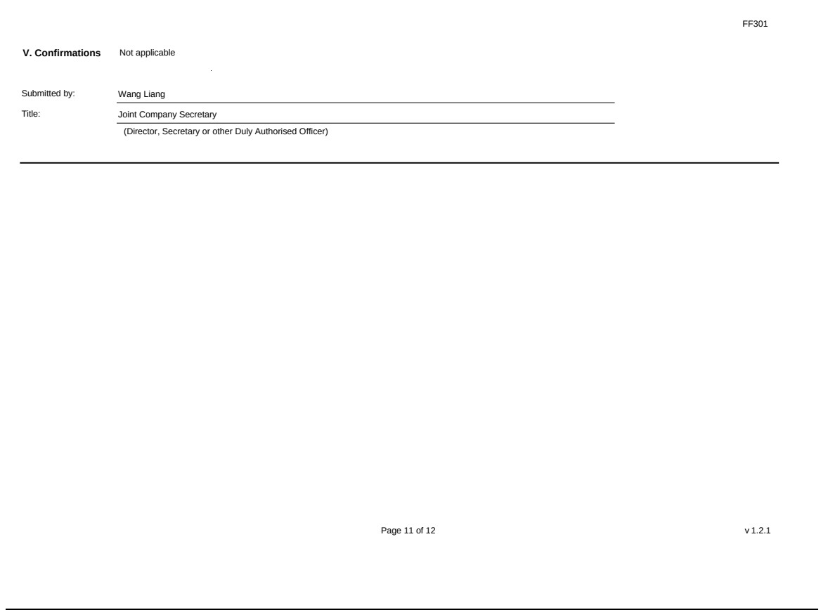

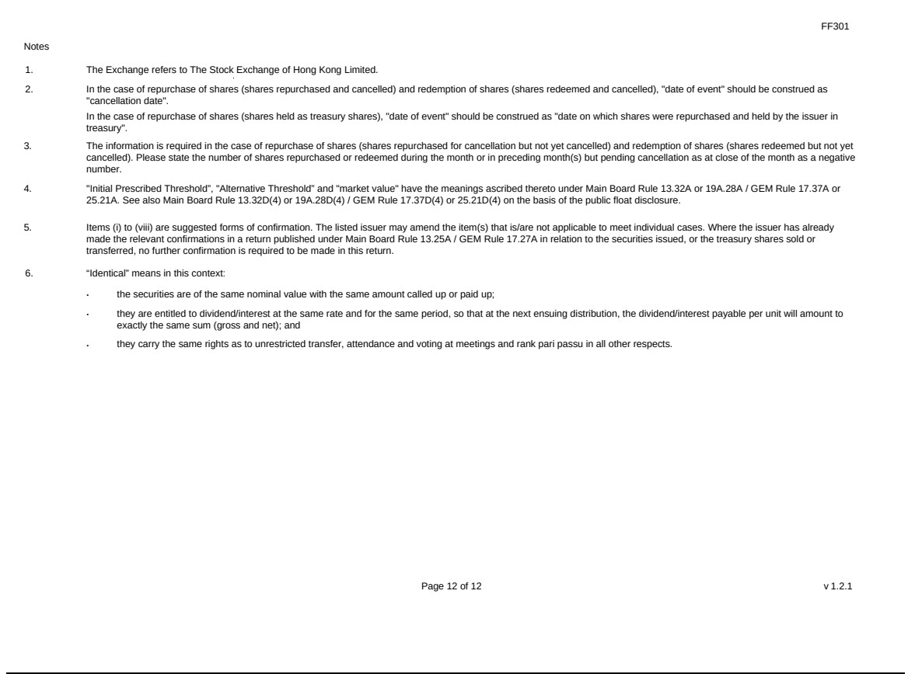

Exhibit 99.2


